# Information Visualization

# CHECKPOINT III: Visualization Sketch

G01-A

**1. Visual Encoding**

For our variables, we opted for two main visual encodings, depending on the nature of the purposes we were looking for.

To represent the amount medals of each country or coefficient (medals/population) in a ranking, under certain circumstances (time, sport or medal), we used length and position in a bar chart. The length is the amount of medals (labelled) and a different position is assigned to each country (also labelled). This allows us to browse through the countries sorted by number of medals.

To represent the country’s amount of medals or its coefficient on a map, under certain circumstances, we used circles placed over that map (that should be scalable for easy navigation). The size of the circle is determined by the amount of medals or the coefficient (depending on the visualization), and the circle’s position is set using the country’s coordinates. This allows us to navigate through the countries more easily.

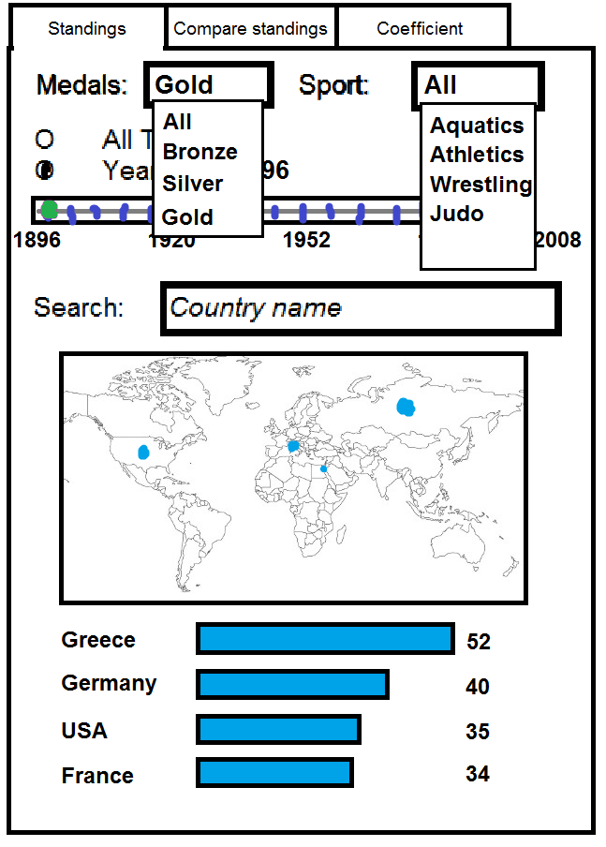**2. Idiom and Tasks/Questions**

* + - 1. First off, to make the marks distinguishable, a country’s circle we have selected on the map will gain a different colour, just like the corresponding bar in the chart (and vice versa, if we select the bar). The countries selected for comparison will also have different colours. The colours were chosen bearing in mind impairments caused by colour-blindness. We can also search for a country using the search bar.
      2. The circumstances mentioned before will decide with pieces of data are displayed. The medal and sports will be chosen in a drop-down menu (top right picture in page 1), also giving the chance of showing information for all the medals or sports at once. The time variable is represented with a timeline, where we drag a slider for the year, with an extra option to represent information for all the years.
      3. 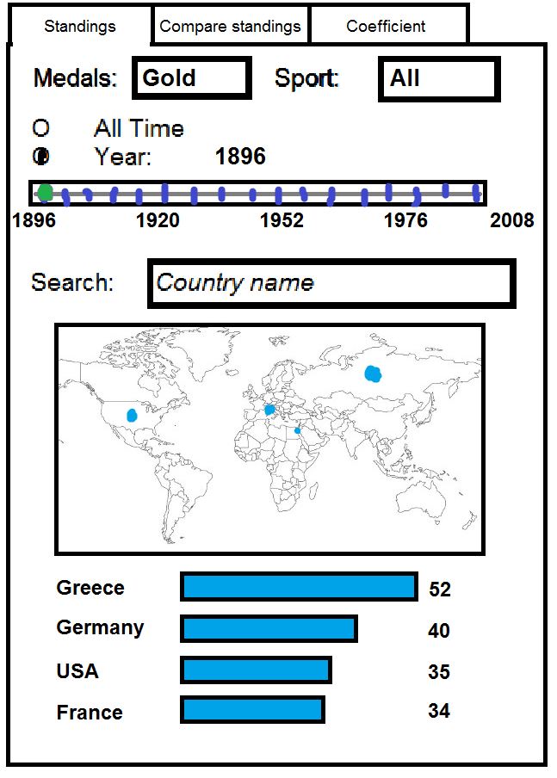The first tab (Standings) shows us the standings of each country concerning the amount of medals it scored in a certain year (or total) and for a sport (or all of them).

General view with Medals and Sport

* + - 1. 1 – What countries had the most gold medalists in the first games, in 1896? In the first tab, selecting only the Gold medal, All for sports, and the year 1896 will give us a ranked list of the countries sorted by medals, and we can see it was Greece who scored the most gold medals that year (bottom right picture in page 1).

2 – What country has the most medalists in Judo? Using the first tab, we can select All the medals, the sport Judo and choose to see the results for all time. Then we can see that Japan is at the top of the results, with the most medals (top left picture in page 2).

Task 1

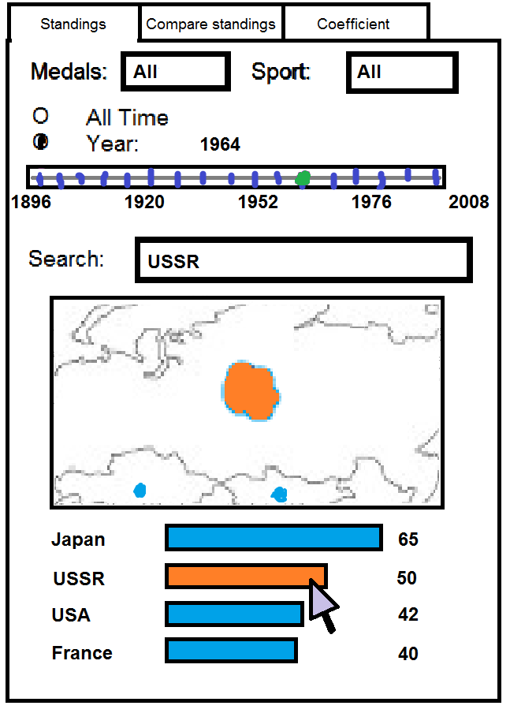3 – What are the standings of the USSR in 1964? Selecting the All medals and the year 1964 will show us the countries with the most medals. We can search for USSR in the 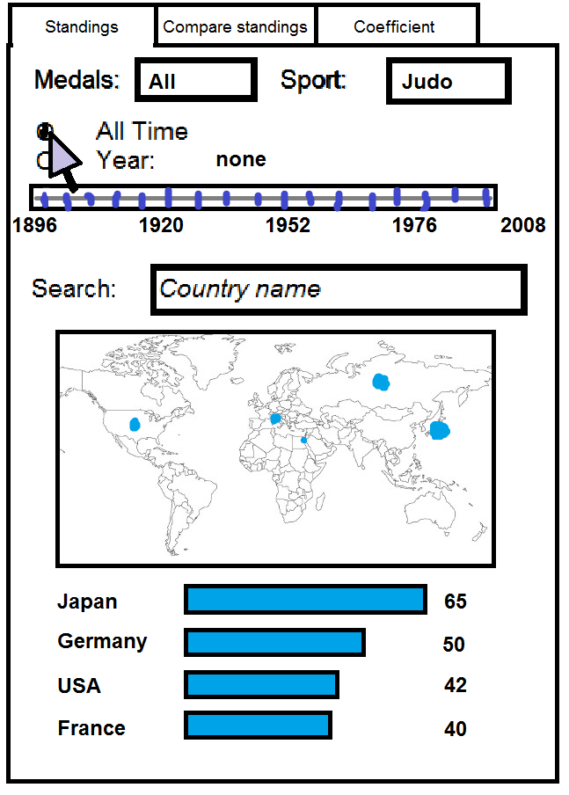search bar to highlight its bar and circle on the map. Instead, we could also scroll down to find its bar in the chart and click it to put it in focus (top right picture in page 2).

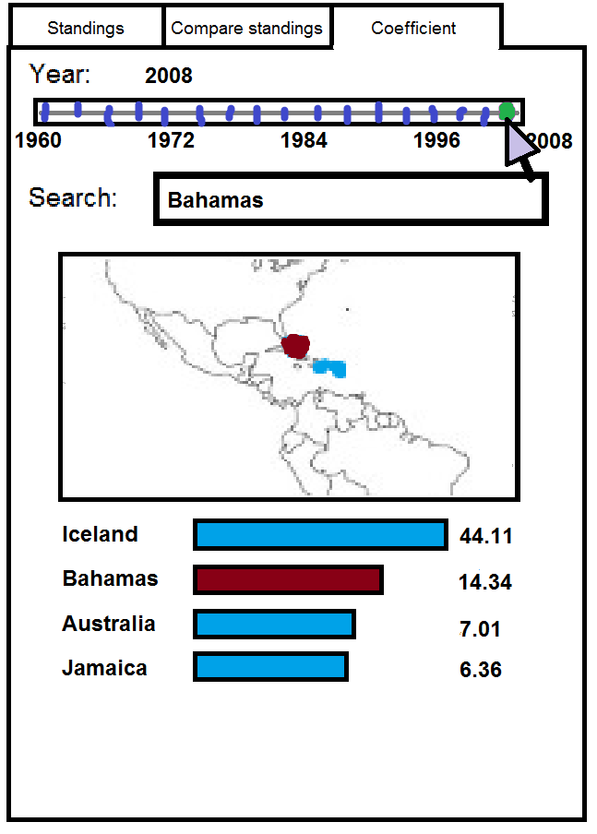The third tab (Coefficient) shows us the standings of each country in a certain year, regarding its medalists/population coefficient. Since we cannot add the population numbers over the years, it doesn’t make sense to see information for all the years. We also only have data for the population since 1960.

Task 2

Task 3

4 – See the countries with the most medalists per capita in 2008. Selecting 2008 will show us the countries with the highest coefficient in that year (center right picture in page 2).

The second tab (Compare standings) allows us to search and select two countries and compare the amount of medals each country has in each sport.

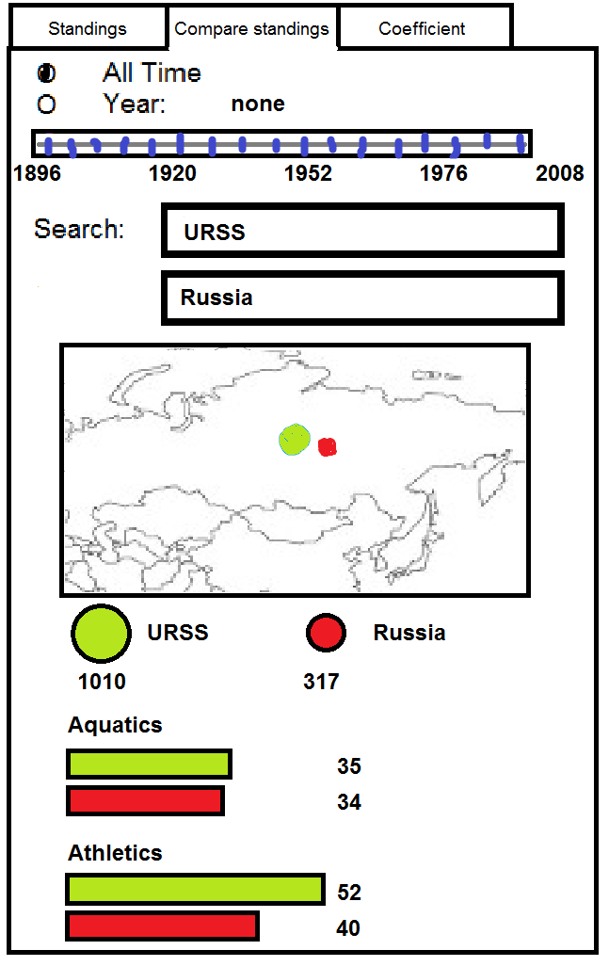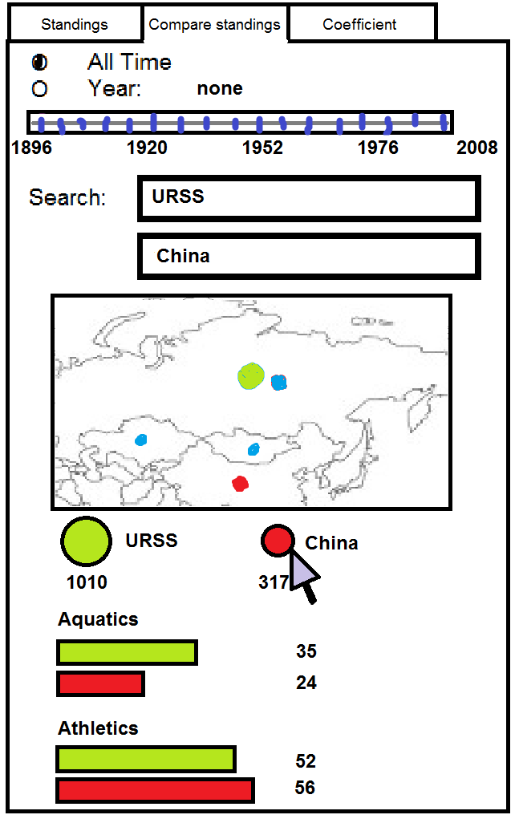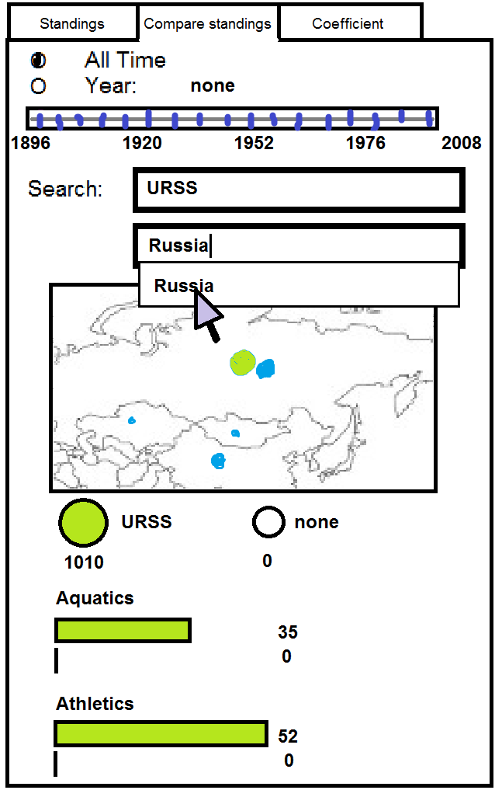5 – How do the USSR and Russia’s cumulative scores compare? Considering we had previously compared the USSR and China’s scores, we can click on China (bottom left picture in page 2) to remove it. Then look for Russia in the second search bar and click on it to add it (bottom middle picture in page 2). It then appears on the second slot of the comparison (bottom right picture in page 2).

Task 5, steps 1, 2 and 3

Task 4